RESOLUTION NO.__________

RE: CERTIFICATE OF APPROPRIATENESS UNDER THE
PROVISIONS OF THE ACT OF THE PENNSYLVANIA
LEGISLATURE 1961, JUNE 13, P.L. 282 (53
SECTION 8004) AND BETHLEHEM ORDINANCE NO.
3952 AS AMENDED.

WHEREAS, it is proposed to install a privacy screen in the rear of the property at 132 E. Market St.

NOW, THEREFORE, BE IT RESOLVED by the Council of the City of Bethlehem that a Certificate of Appropriateness is hereby granted for the proposal.

Sponsored by: (s)

(s)

ADOPTED BY COUNCIL THIS DAY OF

(s)
President of Council

ATTEST:

(s)
City Clerk

HISTORICAL & ARCHITECTURAL REVIEW BOARD

The applicant is proposing to install a privacy screen in the rear of the property at 132 E. Market St.
APPLICATION #1:

Terry & Jean Theman
132 E. Market St.
Bethlehem, PA 18018

OWNER:

__________________________________________________________________________

The Board upon motion by Marsha Fritz and seconded by Connie Postupack adopted the proposal that City Council issue a Certificate of Appropriateness for the following:

- Screen/arbor to be 8ft. in height which includes 12” square lattice and is acceptable because the entire fence will not be solid.

2. The motion was unanimously approved.

__________________________________________________________________________

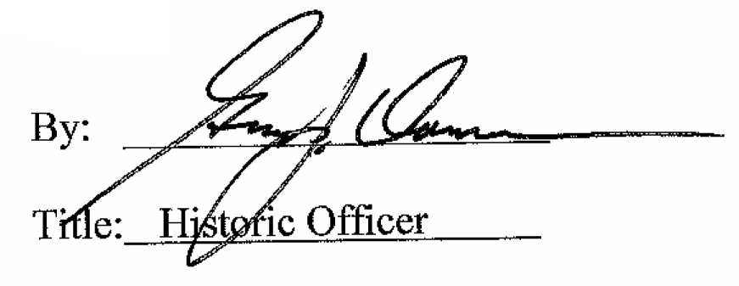

Date of Meeting: August 2, 2017

